Salma Khadra Jayyusi (1926 –)

[summary]
Salma Khadra Jayyusi is an anthologist, translator, literary critic, and poet of Palestinian origins. A writer and researcher in her own right, she is better known for spearheading major projects aimed at introducing Arabic culture, literature, and history to Western audiences. Via the Project of Translation from Arabic (PROTA) and East-West Nexus programmes, she has contributed to and helped to translate and edit dozens of novels, edited collections and anthologies of Arabic poetry, short stories, novellas, and scholarly articles.

[main text]
Poet, literary critic, anthologist, and translator Salma Khadra Jayyusi was born in 1926 in the small Jordanian city of Salt and was raised in Akka in northern Palestine (now Israel) and in Jerusalem, where she attended the elite Schmidt's Girls College. Her father, Subhi al-Khadra, was a Palestinian politician, lawyer and journalist who was subjected to internal exile and imprisonment when Salma was a child; her mother was Lebanese. Jayyusi is often described as having grown up in a household which honoured and enjoyed both Eastern and Western culture and history, which perhaps led her to study Arabic and English literature at the American University of Beirut. Married soon after her graduation to a Jordanian diplomat, she focused on raising her children within the peripatetic lifestyle of the diplomatic service, and only fully devoted herself to her writing, editing and translation work after they were grown.

Jayyusi's first collection of poetry, العودة من النبع الحالم (Return from the Dreamy Fountain) was published in 1960, but she halted work on her second volume as a response to the Six-Day War in 1967, and has published very few of her own poems since. During the 1960s she also translated works of literature and literary criticism by Louise Bogan, Archibald MacLeish and Lawrence Durrell into Arabic. In the late 1960s, Jayyusi turned instead to research, and to writing and translation in English, completing her PhD in London in 1970. This led to her first publications in English, which included her PhD research, published as Trends and Movements in Modern Arabic Poetry in 1977. During the 1970s she taught at the universities of Khartoum, Algiers, Constantine, and Utah. Salma Khadra Jayyusi has lived in the USA since 1975, with links to the universities of Washington, Texas, and Michigan.

Laying aside much of her teaching and research, she has focused the bulk of her career since then on the work of disseminating and promoting Arabic and Islamic culture in the West, with the aim of challenging cultural misunderstanding and misrepresentation. PROTA has attempted to do this via literary translation. The initial seeds for the project were sown in the late 1970s when Jayyusi was invited to work on a major anthology of modern Arabic literature for Columbia University Press. This initiative, funded by the Iraqi Ministry of Information & Culture, eventually led to two significant collections, Modern Arabic Poetry (1987) and The Literature of Modern Arabia (1988).

PROTA itself was officially established in 1980, with the stated aim of ‘the dissemination of Arabic culture and literature abroad’ and with Jayyusi as director. Although her work has obviously been driven by her love of Arabic culture, she has also been trenchant in her criticism of Arab governments and cultural institutions for their failure to support contemporary literature, asking: ‘How can our people, who are in a position of responsibility and who can do something positive and substantial to change the situation...how can they take silence and ignore what only ignorant attitudes can ignore?’ Commentators have also noted that a campaigning spirit lies behind much of PROTA's work, rather than a pretence at scholarly 'neutrality'.

PROTA has been the driving force behind a number of anthologies, single-author collections of short stories or poetry, novellas and novels, issued by many different publishing houses in the USA and UK. The project's subjects have included many of the most significant names in twentieth-century Arabic literature, such as Emile Habibi, Ghassan Kanafani, Hanna Mina and Nizar Qabbani. Jayyusi has written the introductions or forewords to most of these, edited over thirty volumes, and had a hand in translating many of them. From its early days as a small group of academics, PROTA has grown into a loose network of scholars and translators, significant members of which include Roger Allen and Naomi Shihab Nye. Allen and Jayyusi were closely involved in the negotiations which led to Egyptian novelist Naguib Mahfouz being awarded the Nobel Prize for Literature in 1988.

Jayyusi's second major project, East-West Nexus (EWN), aimed to add cultural studies to the literary translation work of PROTA. EWN-sponsored publications have included The Legacy of Muslim Spain, an 1,100-page volume which brought together forty-two contributors, and My Jerusalem, a compendium of ‘essays, reminiscences and poems’ which was partly the outcome of a Fulbright Fellowship during which Jayyusi conducted research amongst Palestinians living in Syria, Jordan, and the West Bank.

Selected Publications

Single-Authored

العودة من النبع الحالم - (al-ʽauda min al-nabʽ al-halim; Return from the Dreamy Fountain), 1960
Trends and Movements in Modern Arabic Poetry. Leiden: Brill, 1977

Edited volumes

Modern Arabic Poetry: An Anthology. New York: Columbia University Press, 1987
The Literature of Modern Arabia. Austin, TX: University of Texas Press, 1988
Anthology of Modern Palestinian Literature. New York: Columbia University Press, 1992
The Legacy of Muslim Spain. Leiden; New York: E. J. Brill, 1992
Modern Arabic Drama: An Anthology (with Roger Allen). Indiana University Press, 1995
Short Arabic Plays: An Anthology. Interlink Books, New York, 2003
Jerusalem in Ancient History and Tradition (with Thomas L. Thompson). London: T&T Clark, 2003
My Jerusalem: Essays, Reminiscences and Poems (with Zafar Ishaq Ansari). Interlink Books, 2004
Modern Arabic Fiction: An Anthology. Columbia University Press, New York, 2005
Beyond the Dunes: An Anthology of Modern Saudi Literature (with Mansour al-Hazimi, Ezzat Khattab), I.B.Tauris, 2006
Tales of Juha: Classic Arab Folk Humor. 2006. Translated by Matthew Sorenson, Faisal Khadra and Christopher Tingley. Interlink
Human Rights in Arab Thought: Ethical Universalism and the Arab Tradition – A Reader. I.B. Tauris, London & New York, 2008
The City in the Islamic World (with Renata Holod, Anttilio Petruccioli, Andre Raymond), Leiden: Brill, 2008
Classical Arabic Stories: an Anthology. Columbia University Press, 2010

Translations

(with Trevor LeGassick, Arabic to English) The Secret life of Saeed: the Pessoptimist by Emile Habibi, 2002
(English to Arabic)
Louise Bogan, 1951 Achievement in American Poetry, 1900-1950 as (1960) نجازات الشعر الأمريكي في نصف قرن
Archibald MacLeish Poetry and Experience (1961) as (1962) الشعر والتجربة
Lawrence Durrell Justine (1957) and Balthazar (1958) – Arabic publication dates unknown

Selected contributions to other volumes

“The Durable Cause of Memory” in Being Palestinian: Personal Reflections on Palestinian Identity in the Diaspora (ed Yasir Suleiman), Edinburgh: Edinburgh University Press, 2016
The Sheltered Quarter: A Tale of a Boyhood in Mecca. Hamza Bogary (Author), Salma Khadra Jayyusi (Editor), Jeremy Reed (Translator). University of Texas Press, 1991
Fan of Swords. Muhammad al-Maghut (Author), Salma Khadra Jayyusi (Introduction), May Jayyusi (Translator), Naomi Shihab Nye (Translator). Boulder: Lynne Riener, 1991

Possible images/video

Lecture by Jayyusi in Jordan and English interpretation of it:
https://www.youtube.com/watch?v=bV8e354P7j4
(from Boston University Librarian Diane D'Almeida's women writers project)

Standard image of Jayyusi to be found in many places on the web. Don't know about copyright but the largest file seems to be here: http://www.arabwomenwriters.com/images/stories/Salma_Jayyussi.jpg

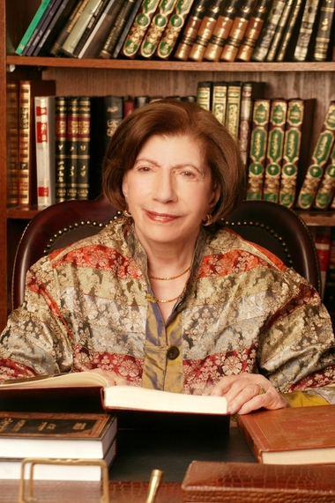
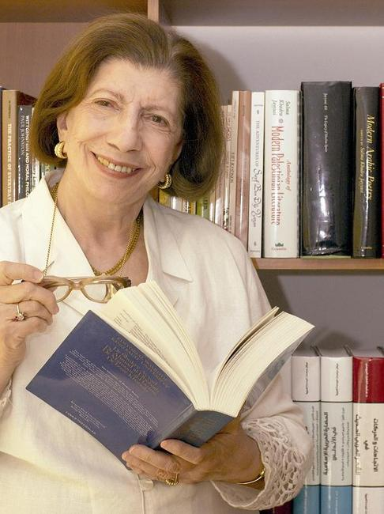

From Arabic online newspaper al-Iqtisadia (Economics)
http://www.aleqt.com/2012/02/20/article_628432.html
copyright page (in English) here: http://www.aleqt.com/page/view/copyright

Speech by Salma Khadra Jayyusi at The Jerusalem Fund, Washington DC, June 2005 http://www.thejerusalemfund.org/ht/d/ContentDetails/i/2583
Richard van Leeuwen, “Review of Anthology of Modern Palestinian Literature by Salma Khadra Jayyusi”. In Journal of Arabic Literature, Vol. 26, No. 3 (Oct., 1995), p.278

